QUALITY ASSURANCE CHECKS
Component | QUALITY CHECK | TIME OF CHECKS | DETAILS
Base | Edges and corners are smooth  No pins protruding  No residue glue  Bases of each foot straight  Four legs fit together securely and the base is flat  Good quality paint finish | After CAD router component cutting  After each foot has been assembled  After painting  During product assembly | On first inspection the heads of some pins protruded slightly and could have caused injury  Two coats of paint were needed to get a good finish  Overall quality was good
Post & Pins | Edges, corners and pin holes are smooth  Groove straight with uniform depth  Good quality paint finish | After cutting, routing and drilling holes  After construction of dowel pins  After painting  During product assembly | Two coats of paint were needed to get a good finish  Some of the pin holes had a poor finish and required extra sanding but overall quality was acceptable
Camera & Circuit Box | Edges and corners are smooth  Unit slides smoothly up and down the post  Doors open and close and are be held tight when closed  No gaps that might allow water to enter  Camera lens and sensor hole in correct position  Good quality paint finish | After CAD router component cutting  After hand-cutting of other wooden components  After assembly of unit  After painting  During product assembly  During product testing | Two coats of paint were needed to get a good finish and a lot of sanding was required  I was very pleased with the finish and function of the most complicated component of the project. The servo motor driven plate moved smoothly and the camera worked well
Feeding table | Edges and corners are smooth  Two plates are identical to allow for uniform distribution of pressure on FDR.  Good quality paint finish | After hand-cutting of other wooden components  After assembly of unit  After painting | I was important to make sure that the holes drilled in each corner of the both plates were aligned so that the bolts fitted squarely and could be tightened smoothly. This was achieved
Roof | Edges and corners and tiles are smooth  Unit slides smoothly up and down the post  Roof top hinges operate smoothly and roof is held securely by magnets  Good quality paint finish | After CAD router component cutting  After assembly of unit  After painting  During product assembly | The tiles required a lot of filing to ensure that the curved edge was smooth and regular. The hot glue held the tiles firmly in position even through there was a small area of contact with the roof top. Painting the tiles a different colour gave pleasing result
Bird Bath | Edges and corners are smooth  Unit slides smoothly up and down the post  Good quality paint finish  Glass bowl is held securely by magnets | After CAD router component cutting  After painting  During product assembly | The only issue with this component was that the back plate started to separate due to the weight of the glass bowl. It was successfully re-glued and pinned back it place
Solar Powered Fountain | Silicon seal between roof and solar panel is waterproof  Test function – fountain operates satisfactorily | When silicon is dry  During product testing | The solar powered pump worked very well and produced a 20cm high fountain of water when the sun was at its highest point in the sky
Arduino Circuit Board & Cabling | Ensure panel and components are securely attached to the box. Check circuit functionality to prove correct cable connections have been made | After construction  During product testing | The circuit function to specification and is held in place with 2 screws making it easy to remove
PLAN FOR PRODUCTION
STAGE | OVERVIEW | TOOLS & MATERIALS | ESTIMATED  TIME (HRS) | HEALTH & SAFETY CONSIDERATIONS | EVALUATION
Base plates | Create the 16 components of the bird table base | 2DDesign programme / CAD Router / 9mm plywood | 3 | Wear safety goggles, and mask to provide protection from dust and debris | The design and routing went according to plan
Formers | Create the 6 formers which form the centre section of the feeding table, roof and birdbath | 2DDesign programme / CAD Router / 9mm plywood | 2 |  | The design and routing went according to plan
Tiles | Create 20 tile strips that will be glued to the roof top to give an attractive finish | 2DDesign programme / CAD Router / 4mm plywood | 2 |  | This stage was very difficult because the 4mm plywood had to be very well secured to a base plate using double sided tape otherwise the plywood would split
Base assembly | Create 4 interlocking feet. Each is made by joining 4 pre-cut components | Hammer, pins, wood glue | 1 | Ensure that sufficient glue and pins are used. | The units fitted together well to form a rigid and flat base
Post | Cut post to length.  Drill holes along the length at 15cm intervals to contain dowel pins.  Cut a groove along the length of the post to hold the solar panel power cable | Hand saw  Drill with 12mm bit  Router  Wood Preservative | 1 | Wear safety goggles, and mask to provide protection from dust and debris | The post fitted firmly into the base and was held firmly by the dowel pins. There was some splitting of the wood when drilling due to the large diameter of the drill bit and this had to be made smooth use in file
Dowel Pins | Pins sit in hoes in post and provide locator for feeding table and bird bath | Hand saw. Drill with 3mm bit. 10mm dowel. Bamboo kebab sticks. Epoxy resin | 1 | Avoid contact with epoxy resin | Production went according to plan
Feeding table  Camera & Circuit Box | Assemble the main unit from pre-cut formers and a number of hand-cut 9mm plywood and softwood pieces.  Attach doors. Drill holes for camera sensor and lens, servo motor and buzzer | Hand saw. Hammer, pins, wood glue  Screwdriver and screws  Hinges and plastic strips for door  Epoxy resin. Nuts, bolts washers for FDR feeding table unit and camera mount.  Drill with 30mm hole cutter  Wood Preservative | 8 | Avoid contact with epoxy resin  Wear safety goggles when drilling holes | This was the most complicated stage of production and took longer than expected. Care had to be taken to ensure than all hand-cut components were exactly the correct size, and that all components were joined accurately. The unit could not be held securely when drilling the holes causing some raggedness
Roof | Assemble the roof unit from pre-cut formers and a number of hand-cut 9mm plywood and softwood pieces.  Glue pre-cut tiles in place. | Hand saw. Hammer, pins, wood glue  Screwdriver and screws  Epoxy resin. Magnets and metal strip.  Hot Glue gun. Wood Preservative | 6 | Avoid contact with epoxy resin. | This stage was also complicated. Cutting and gluing of the tiles took longer than expected but the finish was good.
Bird Bath | Assemble the bath support from pre-cut formers and a number of hand cut 9mm plywood and softwood pieces | Hand saw. Hammer, pins, wood glue  Screwdriver and screws  Epoxy resin. Magnets and metal washers.  Glass bowl. Wood Preservative | 3 | Avoid contact with epoxy resin. | Construction was quite straight forward and the bird bath sat securely in the unit. The addition of washers glued to the bowl + magnets in the in the base ensured the bowl would not the knocked out by large birds
Solar Powered Fountain | Attach solar panel to top of roof | Drill with 50mm hole cutter  Silicon sealant | 1 | Wear safety goggles when drilling hole. Avoid contact with silicon sealant. | Production went according to plan
Arduino Circuit Board & Cabling | Attach UNO board and bread board to 6mm plywood base and attach to main unit. Attach servo and buzzer and owl face and cover to main unit. | 6mm plywood, screws, epoxy resin | 2 | All edges to be hand sanded at checked for sharp edges and splinters. | This was quite a fiddly job as a lot of components has to be fitting into a small space and cables connected
CAD ROUTER
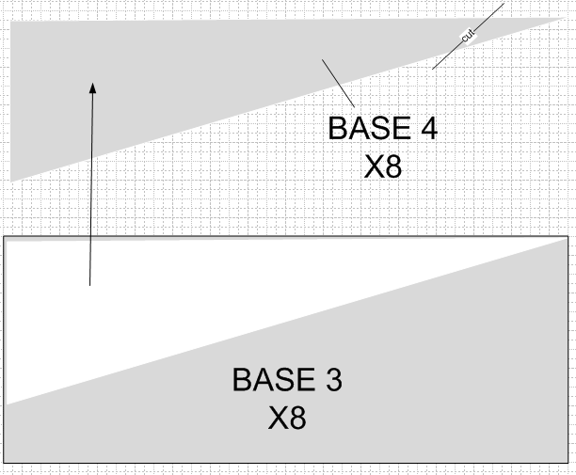
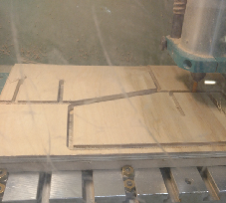
I then cut out the middle and end sections from 9mm plywood. Each leg requires two middle sections and one end section. The sections that make each leg will be pinned and glued together later
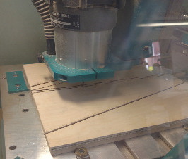
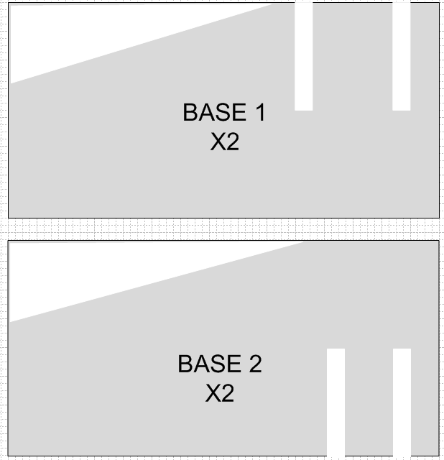
The table has 4 legs each constructed from 4 sections of 9mm plywood. The top section of each of the legs slot together to form a cross shape with an open square in the middle to take the post. I started by cutting out these 4 sections

X4

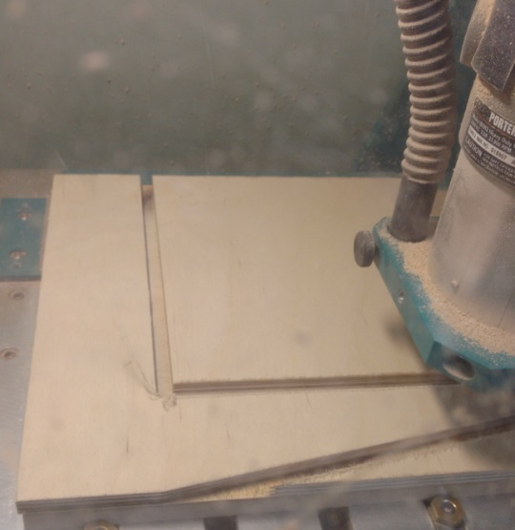
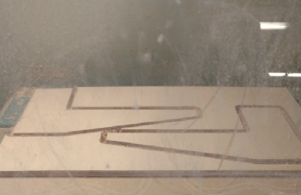
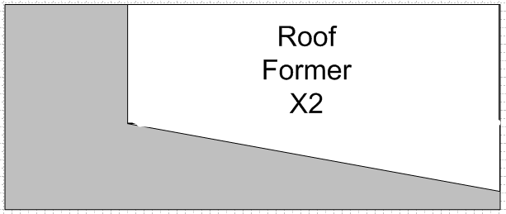
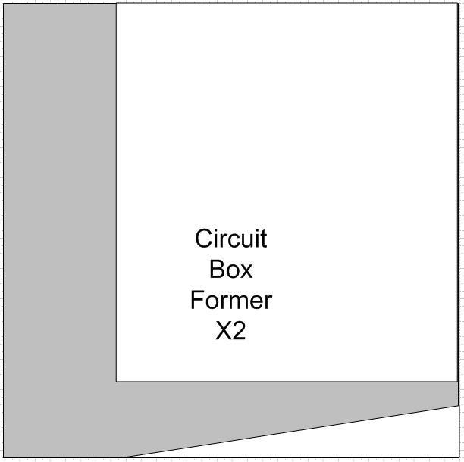
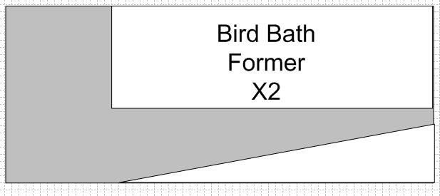
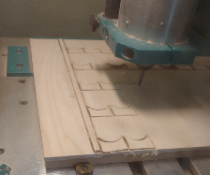
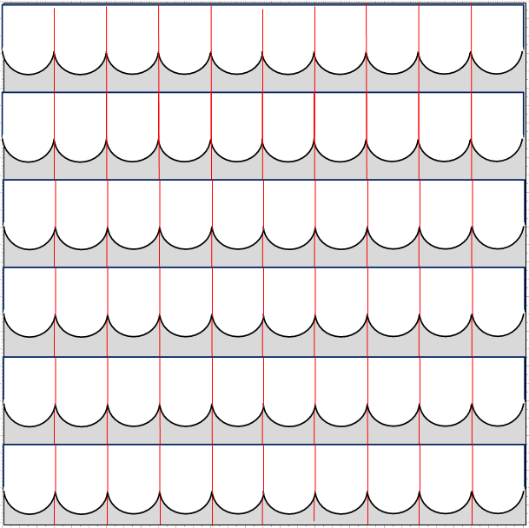
The roof tiles are cut in strips from 4mm plywood. Each tile is 30mm wide and 40mm long with a semi-circular end. 5 strips were cut from each sheet of plywood and a total of 20 strips were made. The Plymouth had to be very securely taped to the CAD to ensure that the 4mm plywood was not split by the router.
The circuit/camera box and feeding table L-shaped support component has a longer back section than the other components because it weighs more. The back section is used to create the tube which runs up and down the post and supports it’s CofG which is in front of the post.

The bird bath support is one of three components requiring two L-shaped formers to be cut from 9mm plywood. In each case the base on the L-shape is tapered to minimize weight without reducing strength.

The main body of the roof component also requires two L-shaped formers to be cut from 9mm plywood. The base is flat to support the base section of the roof box.

